We are designing a marketing landing page for this app

You are designing the landing page now. We will then go into onboarding, for now, this is the landing page

Directions:

Use the headspace design as guidance on spacing.

Use the starbucks colors (dark green) that has been in our app for the landing pages colors

Use the two screenshots of the App (nighttime feeds) with the corrections listed below, put this where the headspace screenshots are.

The CTA is positioned like Headspace, above the fold.

Optimzie for desktop and mobile.

Below the fold, peaking out is the testimonials. See below

Design and Copy:

*[put this where the limited time is for headspace]*

*Designed for infants 0-5 months*

Headline:

Sleep through the night

Subheader:

Track your feeds. Avoid nighttime wake-ups.

*Button: Check it out*

This night time feed screenshot - we need mock up changes  
For week 10, please edit the mock up -- time between feeds is 3h 05 min (replace the 0)  
For week 11, add Longest night time stretch is 9 hours and 7 minutes to the mock up  
Change the purple headline on top to be 9 hours and 7 minutes (not 8 hours and 47m)

Below the 7pm to 7am put  
  
 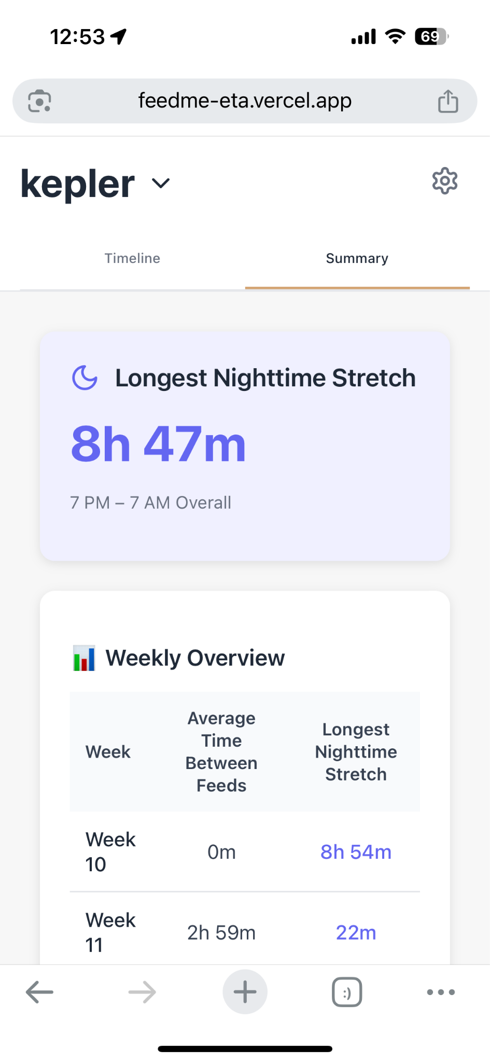

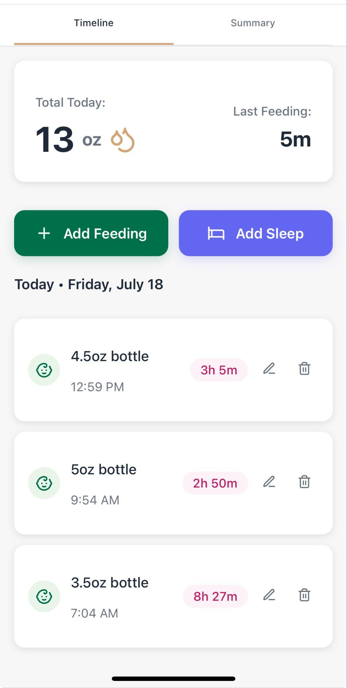

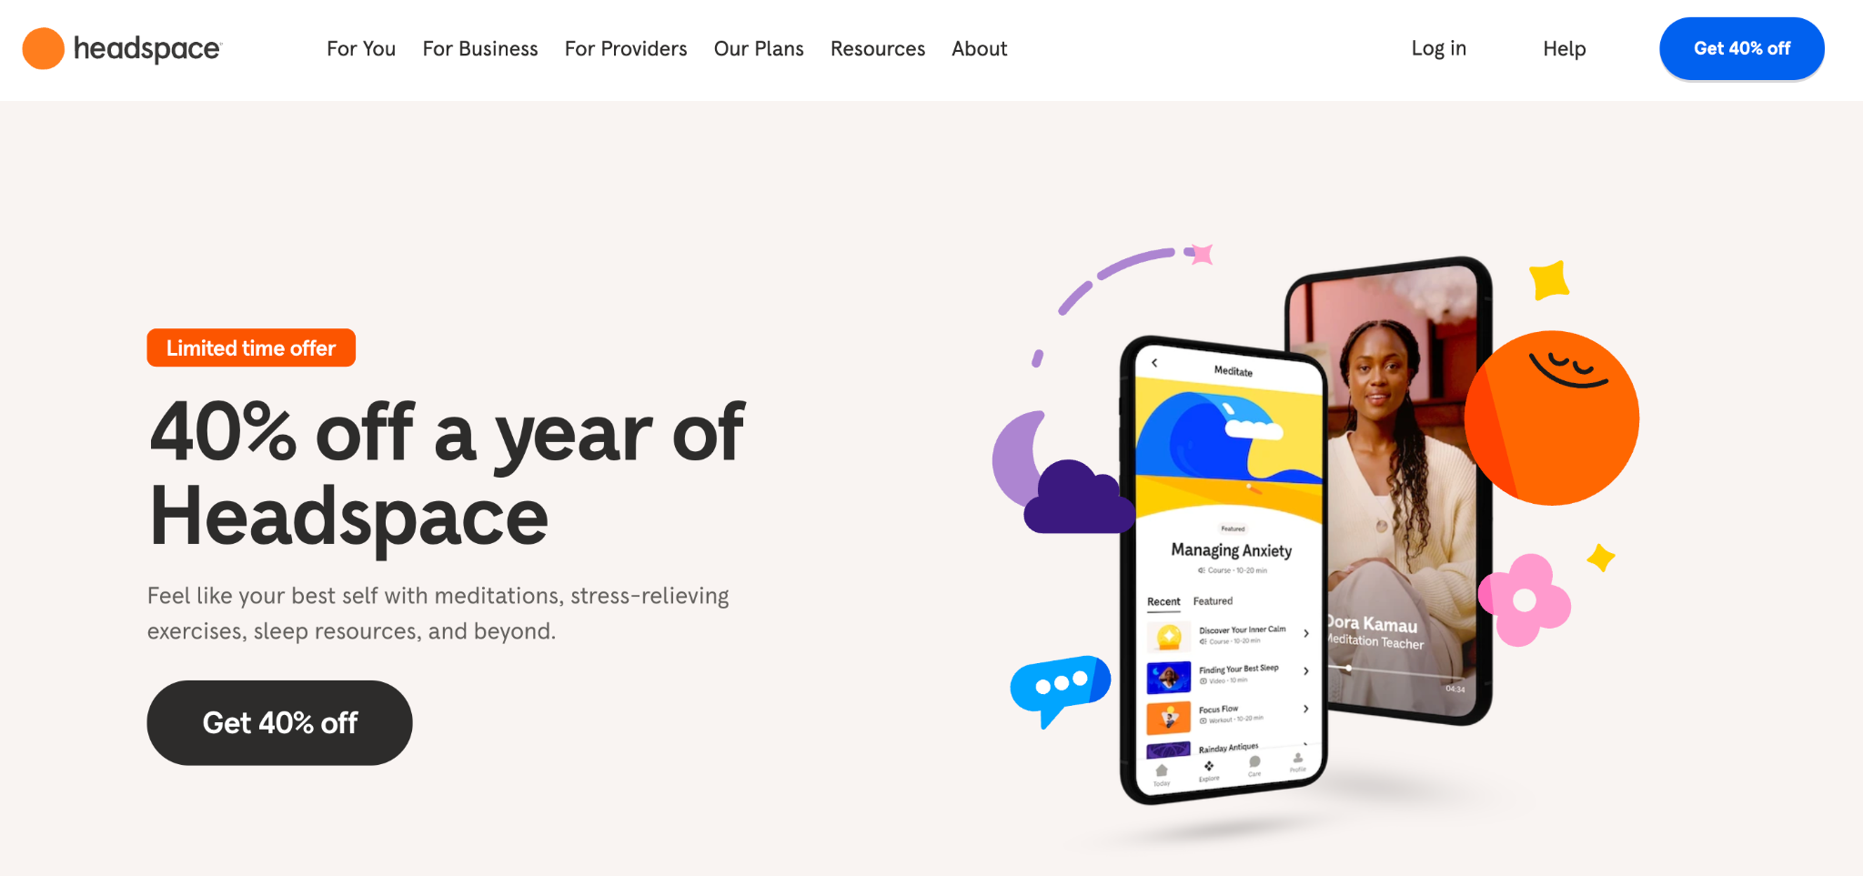

These should have faces (pictures of people)  
The three testimonials should be:   
This app helps your baby sleep through the night faster” Sarah, Night Doula for tech founders

“Sleeping through the night is about daytime feeding. I tell all my clients to track ” Julie, night doula for celebs  
“Most babies can go 8 hours by 8 weeks. It’s the parents we need to train. This app helps you” Claire, bay area night nanny.

